**Batch: B2 Roll No.: 16014022050**

**Experiment No.: 1**

**Grade: AA / AB / BB / BC / CC / CD / DD**

**Signature of the staff in-charge with date**

Ccff

**Experiment No.: 3**

|  |
| --- |
| **TITLE:** Building and configuring simple topology using Network tool - CISCO PACKET TRACER. |

**AIM:** To build and configure simple network topology using CISCO Packet Tracer.

**Expected Outcome of Experiment:**

**CO1:** Explain the fundamentals of the data communication networks, reference models, topologies, physical media, devices, simulators and identify their use in day-to-day networks.

**Books / Journals / Websites Referred:**

1. <http://www.google.com>
2. A. S. Tanenbaum, “Computer Networks”, Pearson Education, Fourth Edition
3. B. A. Forouzan, “Data Communications and Networking”, TMH, Fourth Edition
4. CISCO PACKET TRACER 8.0.1 and Higher version (free download)

**Pre Lab / Prior Concepts:** Simple network flow

**New concepts to be learned:** Purpose of this lab is to become familiar with building topologies in Packet Tracer.

**Theory**

**Stepwise-Procedure**

Creating a simple LAN network using packet tracer:

Step 1: Select two PCs (PC0 and PC1) from the end devices and one fast ethernet switch (2950/24 ports)

Step 2: Connect PCs and switch via copper cable from the panel. Connection can be verified by appearance of all green dots on the links.

Step 3: For PCs to communicate click on PC0.

* Dialog box for PC0 appears
* Click on desktop applications by packet tracer.
* Go to IP configuration.
* Enter IP address to identify host i.e. PC0 (for example: 192.168.1.1)
* Subnet mask-by default already set one can change it as per his/her specification.

Step 4: Repeat step 3 for PC1

Step 5: Ping both the PCs and check their working status.

Step 6: Simple PDU (Protocol Data Unit) to simulate network traffic by sending ICMP PDU to assess the network traffic. View simulation in simulation mode

**Network Topologies:**

1. **Topology with a HUB**

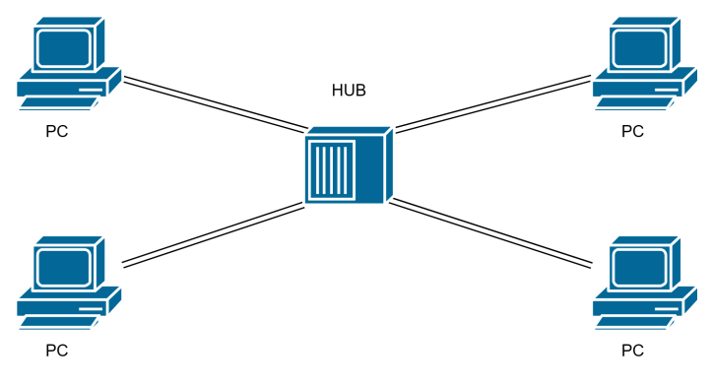

1. **Topology with a Switch**

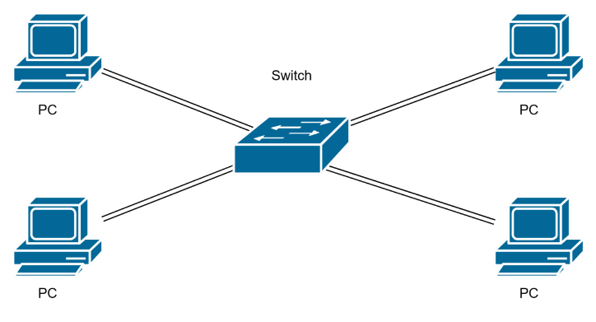

1. **Topology with two switches**

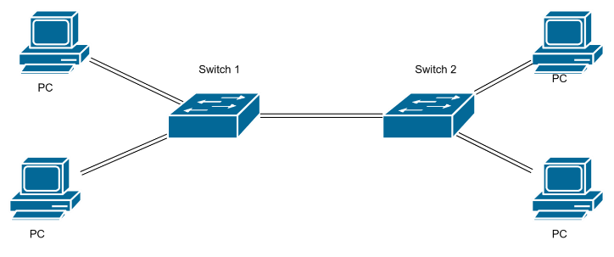

1. **Topology with 3 switches in a loop (Concept of STP)**

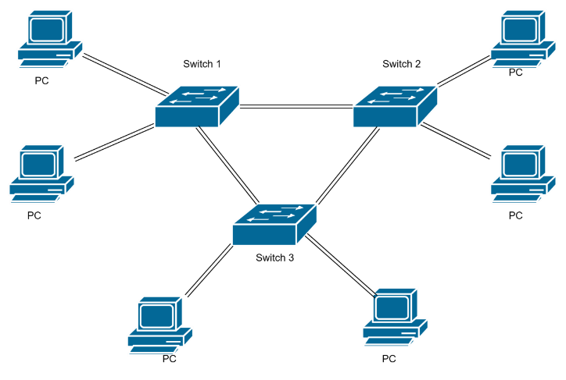

**Implementation**

1. **Topology with a HUB**

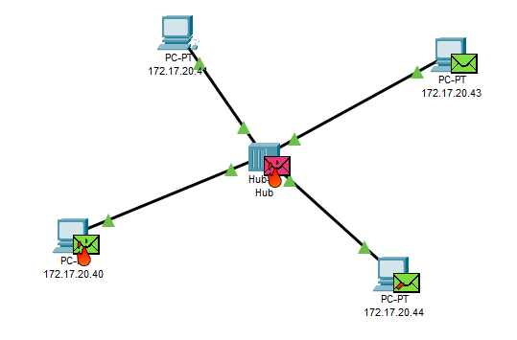

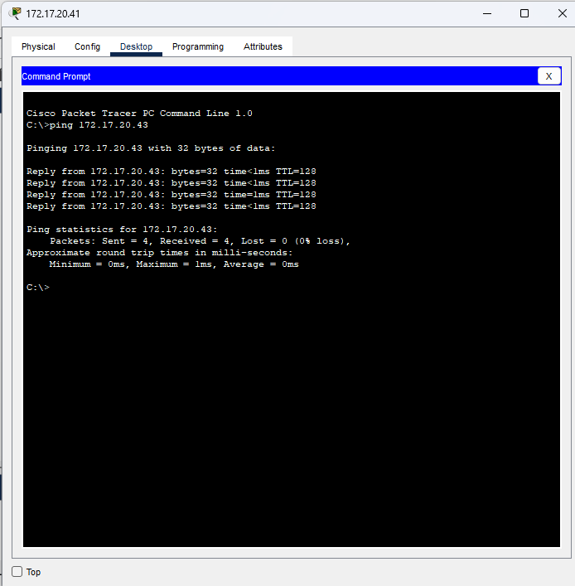

1. **Topology with a Switch**

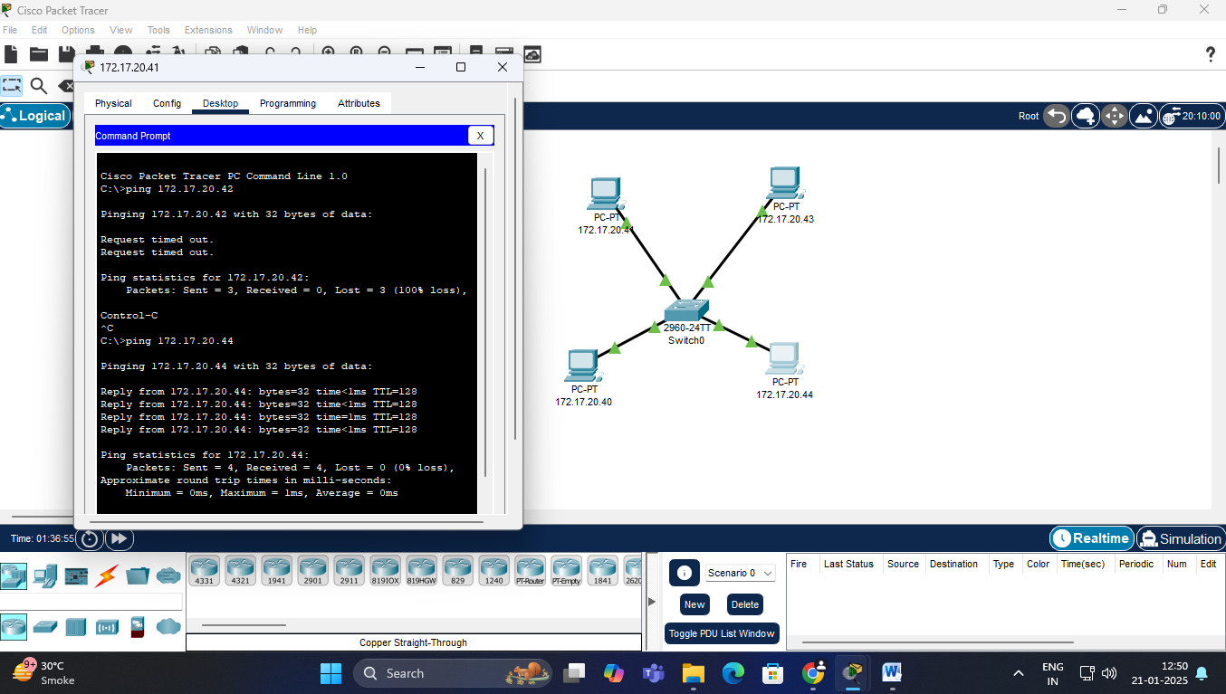

1. **Topology with two switches**

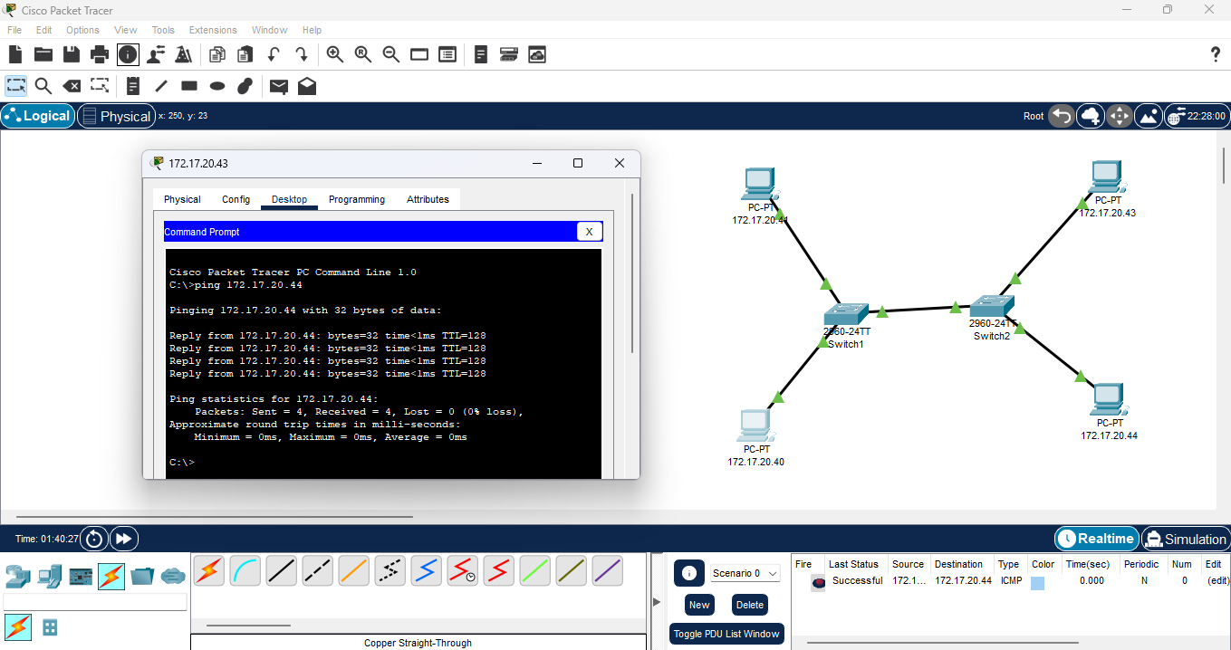

1. **Topology with 3 switches in a loop (Concept of STP)**

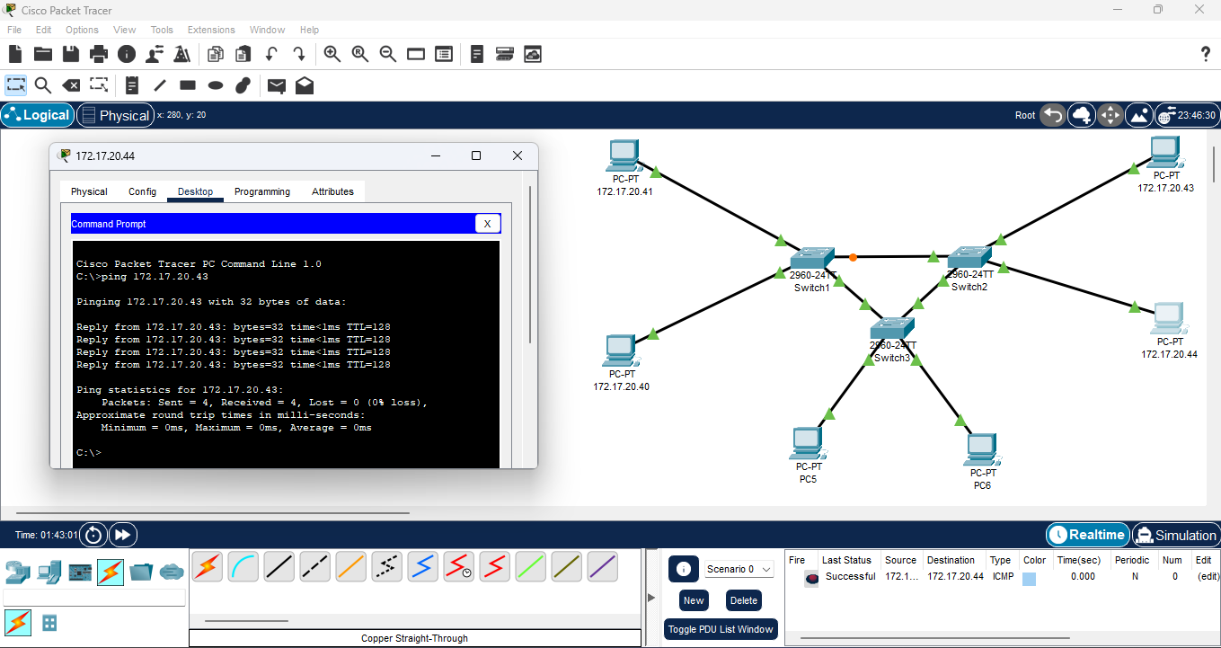

**Conclusion:**

We successfully created different LANs using hubs, switches, and other network devices in Cisco Packet Tracer. This demonstrated how network topology affects communication and the efficiency of data transfer within a LAN.

**Post Lab Questions:**

1. **List features of CISCO packet tracer.**

* Simulation of network topologies with routers, switches, hubs, etc.
* Supports various protocols (HTTP, FTP, DHCP, etc.) for real-world simulation.
* Provides real-time and simulation models for testing and analysis.
* User-friendly interface for creating and managing network layouts.
* Learning tools for troubleshooting, configuration, and protocol understanding.

1. **Explain difference between working of a Hub and a Switch in a given topology.**

* **Hub**: Broadcasts data to all connected devices, causing network congestion and lower security.
* **Switch**: Directs data to the specific recipient using MAC addresses, improving efficiency and security.

1. **Differentiate between Active and Passive Hub.**

* **Active Hub**: Amplifies incoming signals and requires an external power source.
* **Passive Hub**: Simply connects devices without amplifying signals, relying on the network's power.

1. **What is the difference between L2 and L3 switch?**

* **L2 Switch**: Operates at the Data Link Layer, forwards data based on MAC addresses, and does not support routing.
* **L3 Switch**: Operates at the Network Layer, can route data based on IP addresses, and supports VLANs and inter-VLAN routing.